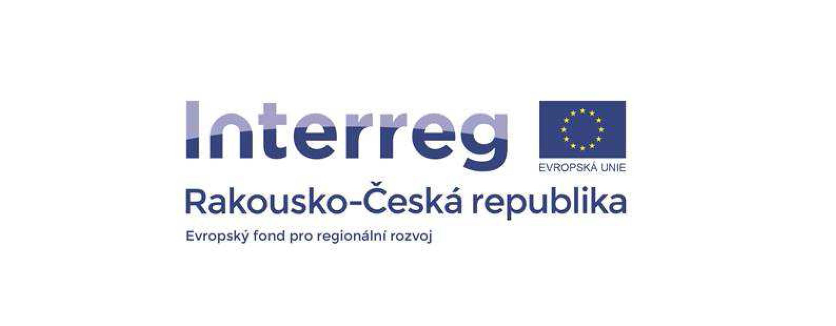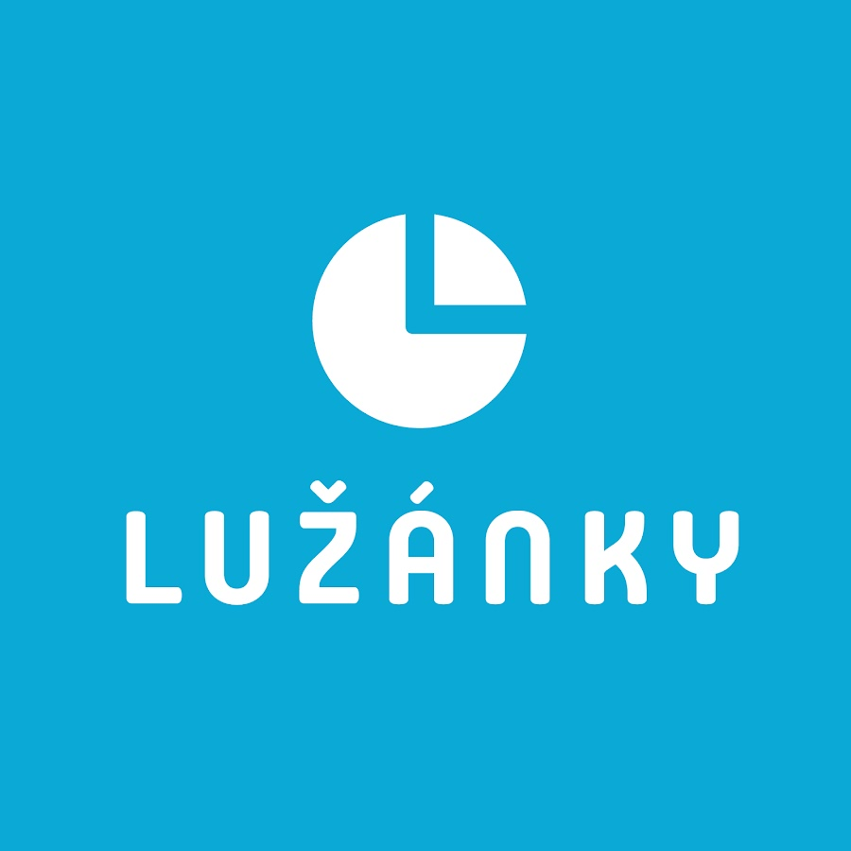

3D map - Dolní Dunajovice
Dolní Dunajovice elementary school and kindergarten, contribution organisation

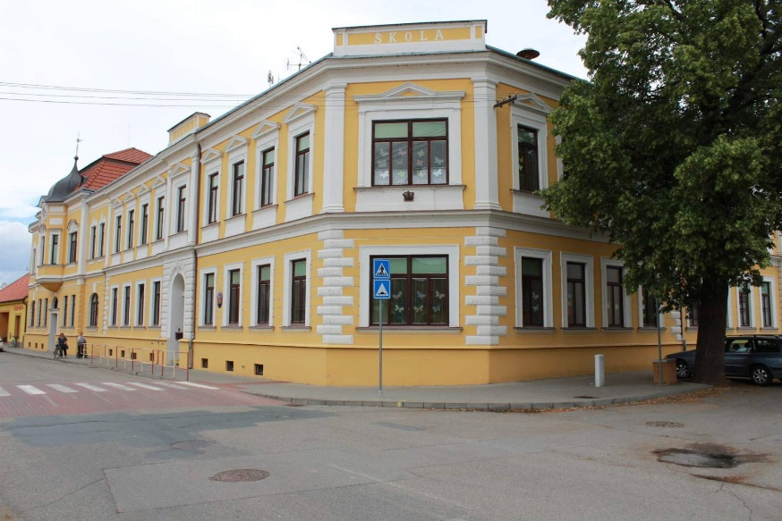

Project information
The goal of the project "3D map of interesting places around Dolní Dunajovice" is to make available to our students new and more modern IT technologies, such as 3D printers and other robotic elements, which we would like to use in the processing of the project in addition. Another goal is, thanks to the work of our students, to contribute an interesting product that will find use for other needs as well.
Considering that our village is very interesting for tourists, we decided to create a map for our information centre, which will show the most interesting places around our village.
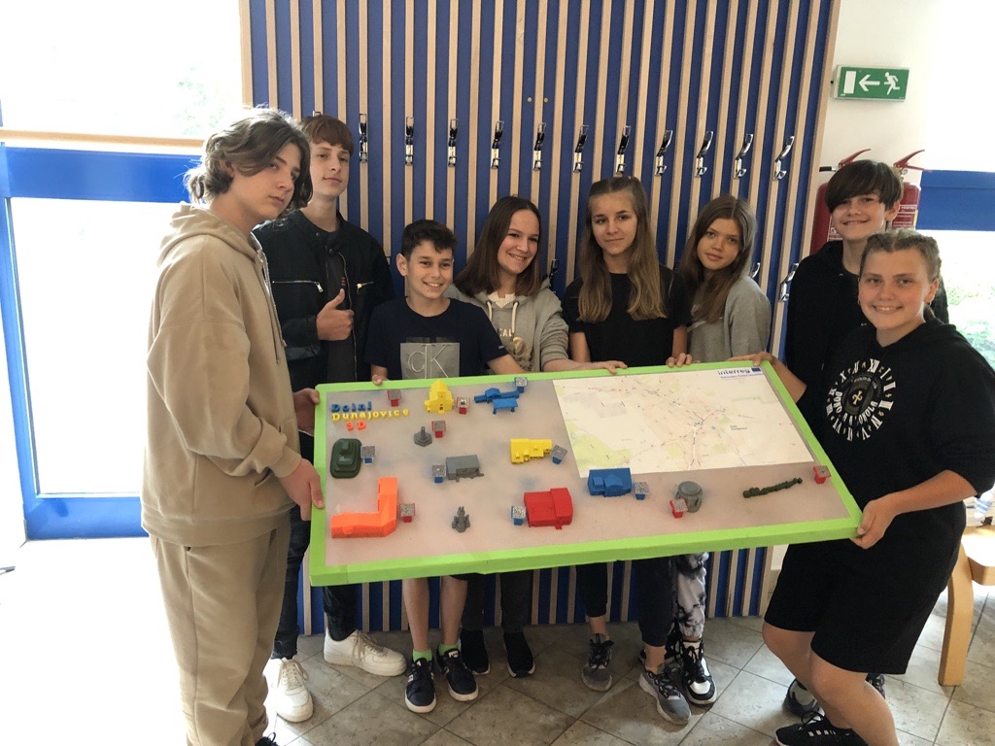
Project objectives
Pupils will create a 3D map of Dolní Dunajovice and its surroundings, where they will use 3D printing technology.
Pupils suggest how the map should look.
Pupils select and process information about the places they want to display in 3D.
Pupils create 3D places that they insert into the map of the village.
Pupils will install the map in the local information centre.
Pupils will prepare a presentation that will promote their creation.

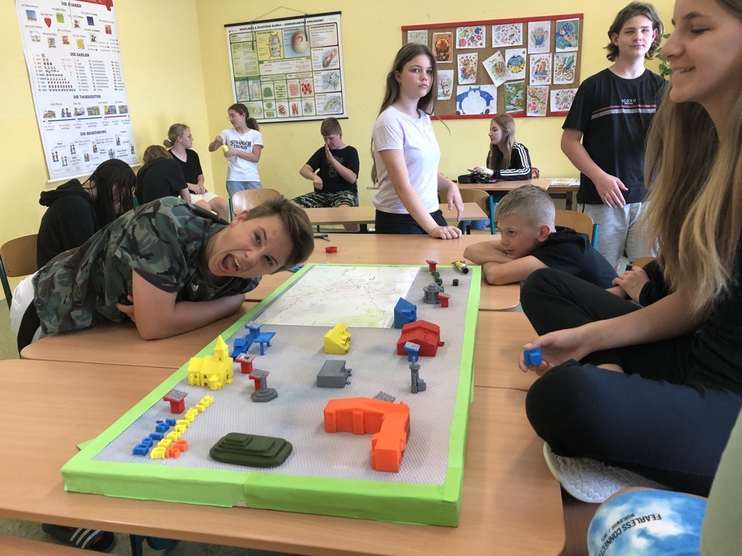

Our content
1. What we used to implement our project
2. Training where we learned various important information
3. Tinkercad and Prusa slicer programs
4. Deciding which buildings to choose for our project
5. Drawing and assembling buildings
6. Creating QR codes
7. Assembling and gluing a 3D map with QR codes

Material equipment

Original Prusa i3 MK3S+ 3D printer kit (2 pcs)

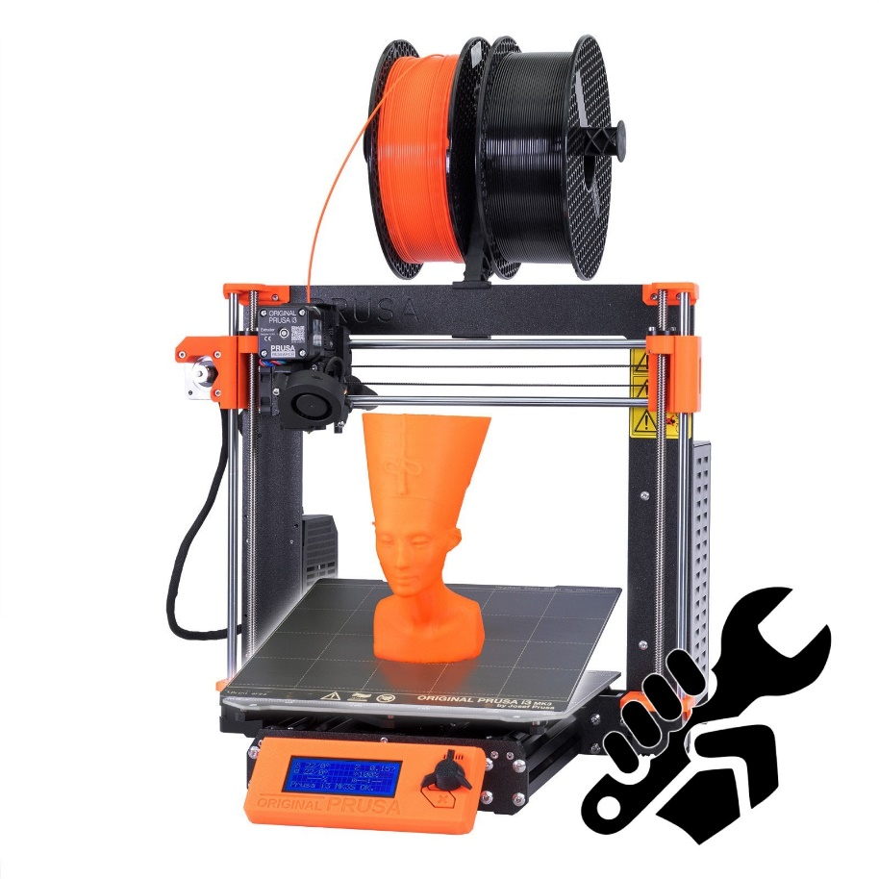
As part of the project, the pupils were introduced to the function and use of a 3D printer, not only thanks to a presentation organised as part of the project by two external workers from the DigiMe project, who introduced the pupils to this device, which is in our school's computer science classroom. The printer was used not only within the project, but thanks to it we have produced, for example, name tags on the doors of teachers' offices and classrooms.

We also needed any computer or notebook to work on the programs.

Programs used

Tinkercad
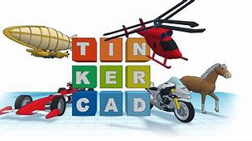
- Tinkercad is a free online 3D modelling program.
- Since its launch in 2011, it has become a popular platform.
- The design is made up of primitive shapes that are either solid or holey.
- By combining solids and holes together, new shapes can be created that can be assigned a solid or hole property.

Prusa Slicer
- PrusaSlicer is an application for converting 3D models.
- Over time, the Prusa i3 design has become one of the most popular designs.
- Appears in many adaptations around the world.
- 3D printers can also print parts on another machine.

In these two programs, we first created models that we later started printing on the aforementioned Original Prusa i3 MK3S+ printer

Website Planet
- A QR code is a means of automated data collection.
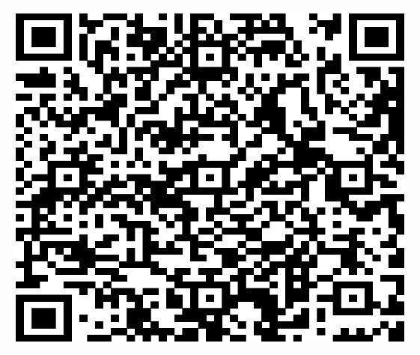
- A QR code is a means of automated data collection.
- We created QR codes on the free QR code generator – website planet.

Phases of our project

1st phase of the project (as time went by)

- We have decided to join the DigiMe program.
- On Friday, November 12, we took part in a "training" for 3D printing.
- In the first phase, we got acquainted with the theory of 3D printing.
- What was surprising to us was that 3D printing is also used in space.
- When we got the 3D printers, we tried to assemble them.
- First we had to learn how to work in Tinkercad.
- We started printing the buildings of our village

2nd phase of the project (we are finally printing)
• We didn't do well at first, but then it got better.
• In the beginning, we tried only the documents, later we tried to print individual buildings (small, large and, above all, accurate).
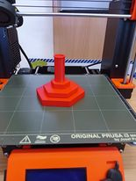
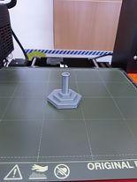
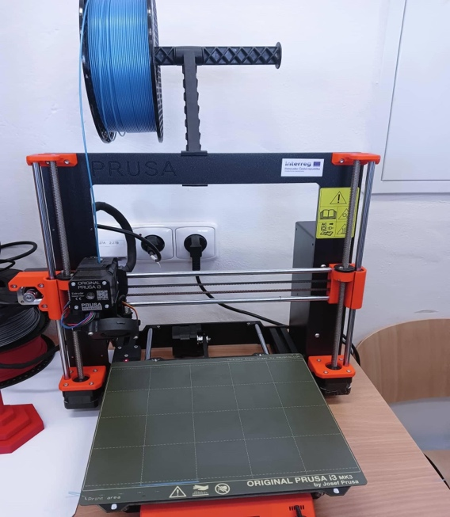
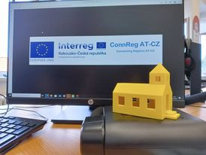
• We use filament for the printer, we have different colours.

List of buildings that appear on the 3D map

- Church of St. Lily
- Dolní Dunajovice Elementary school
- Municipal office
- House Dr. Karl Renner
- Cellars of Dunajovice
- Pillory
- Statue of St. Cyril and Methodius
- Monument to the victims of the 1st and 2nd World Wars
- Coop – grocery store
- Gas station
- Sunny Hill
- Restaurant Prague

The final phase of the project

After several successful and unsuccessful attempts, we printed all the buildings and started sticking them on our map of Dolní Dunajovice.
Thanks to this, we improved a lot in 3D printing and learned something.
We created QR codes on the free site www.websiteplanet.com, where we searched the internet directly for sites, or information that we entered into this very intuitive site and it then generated a QR code for us.
We printed these QR codes and stuck them on the stands, which we also designed ourselves in the Tinkercad program.
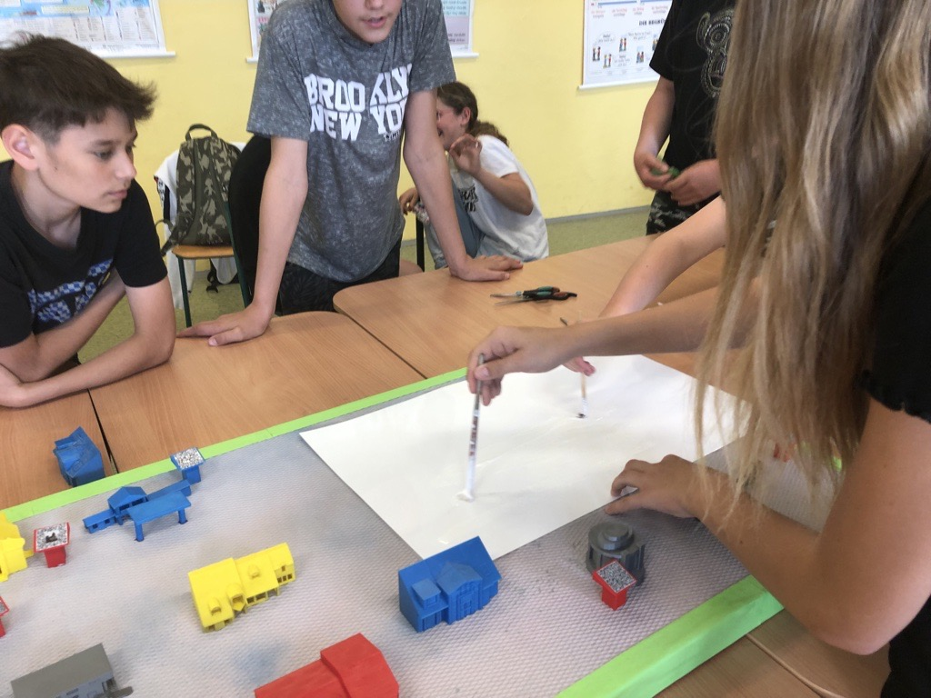
We then created the entire map and pasted the title, which is also 3D printed, and all the buildings that matched the given QR codes and then took everything to the info centre (Karel Renner's house. see p. 2)

Evaluation of the project
We managed to achieve all the goals and we all had a lot of fun. The DigiMe project is unique and we are very grateful to have been a part of it. We learned to work as a team and we really liked that too. We think that the result is really worth it and we hope that our work will continue to serve not only our students, but also tourists for better orientation.

